Data on New Freshman

1. NSSE: How does UNI rate with our cohort institutions related to the three advising questions below? See table below.
FoE Student Survey: How do freshmen who are White/Non Hispanic, provisionally admitted, honors, and protected classes rate advising according to the four advising related items listed?

I can do protected classes, but not provisionally admitted or honors with the FoE survey data.
2. Could the student satisfaction areas in the three NSSE advising items be broken out into two categories: Caucasion and Black/Asian Pacific/ Hispanic/Native American? Yes, see table below.
Do you think it is sufficient to group into only two areas? Yes, I have seen it done this way on various reports.
Do you think we should include athletes? I have included the data and you can decide if you want to use it or not after you look at it! It is pretty interesting, I think.
Was no satisfaction survey done in 2007? Correct, after 2006 it has been done every other year.
I didn't use the mean with no opinion. Should I have? It would have been higher. I sometimes take no opinion out and think it is effective, just always be sure to note that they are removed when you reference the data.
3. Is there a report that lists the gpa of entering freshmen after their first semester? See attached PDF 1
4. Do you know if a student profile was created in 2000 & 2001? I would like the ACT Scores of the entering classes for those years. We did not do a Student Profile in 2000 and 2001.

I want to compare:
ACT Scores of the entering classes We have ACT information by college below.
GPA at the end of the first semester (We have those classified as freshmen, but that could include anyone under 30 hours) See attached PDF 1
persistence See attached PDF 2
time to graduation See attached PDF 2

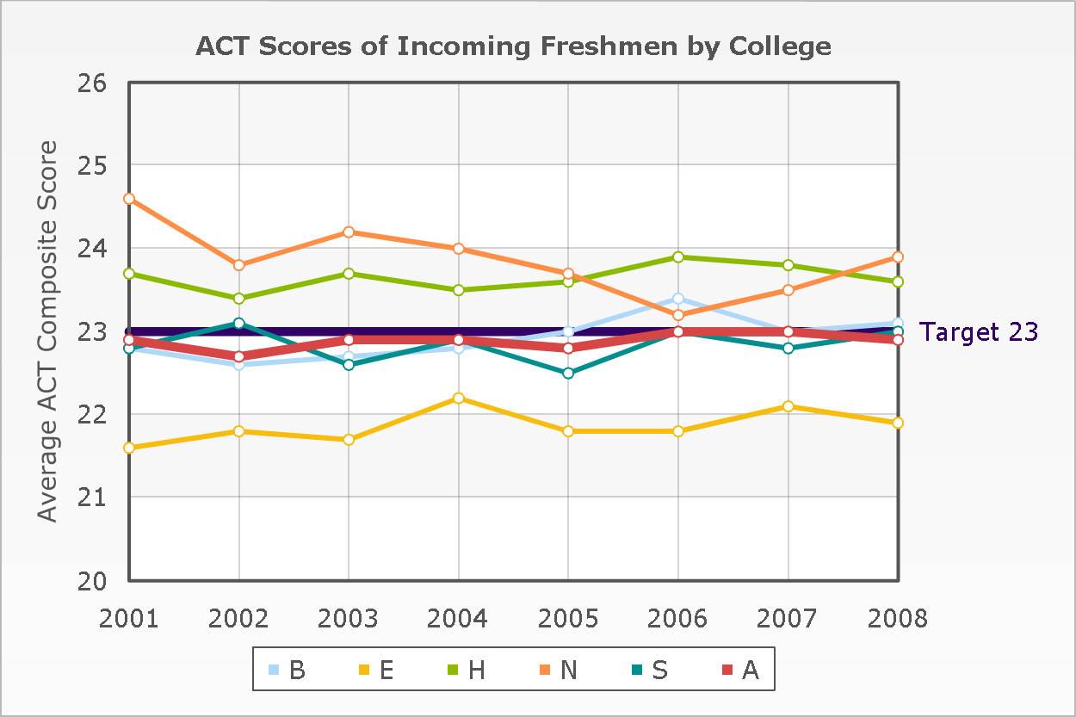
5. Do you know where I should look to find a comparison of UNI's persistence rates to our comparable institutions?

 | Full-time retention rate
 | 2003 | 2004 | 2005 | 2006 | 2007
Northern Arizona University | 69 | 70 | 69 | 72 | 71
California State University-Fresno | Blank | 84 | 86 | 82 | 81
Illinois State University | 83 | 84 | 85 | 84 | 83
Indiana State University | 70 | 68 | 66 | 67 | 69
University of Northern Iowa | 80 | 81 | 80 | 82 | 82
Central Michigan University | 77 | 78 | 77 | 76 | 76
University of Minnesota-Duluth | 74 | 76 | 75 | 76 | 75
University of North Carolina at Greensboro | 75 | 77 | 77 | 76 | 76
Ohio University-Main Campus | 83 | 82 | 81 | 80 | 78
University of North Texas | 75 | 74 | 75 | 76 | 74
University of Wisconsin-Eau Claire | Blank | 79 | 83 | 82 | 82

 | Graduation rate - Bachelor's degree within 6 years, total population
 | 2004 | 2005 | 2006 | 2007
Northern Arizona University | 50 | 48 | 47 | 48
California State University-Fresno | 46 | 43 | 46 | 48
Illinois State University | 62 | 63 | 64 | 65
Indiana State University | 40 | 39 | 41 | 41
University of Northern Iowa | 64 | 65 | 67 | 65
Central Michigan University | 55 | 55 | 57 | 57
University of Minnesota-Duluth | 46 | 48 | 51 | 50
University of North Carolina at Greensboro | 50 | 51 | 52 | 50
Ohio University-Main Campus | 70 | 71 | 71 | 70
University of North Texas | 40 | 43 | 45 | 44
University of Wisconsin-Eau Claire | 57 | 59 | 59 | 60
The blank cells in the charts below indicate the areas I don't have information for.
Student Attitudes Toward Advising
NSSE Data:
NSSE Item | Freshmen | Seniors | Cohort Institutions (NSSE 2007 data)
1 o. Talked about career plans with a faculty member or advisor. | 16% often or very often talked about career plans. | 35% often or very often talked about career plans | FR (28%)  SR (38%)
10 b. The extent UNI provides the support needed to help succeed academically | 78% report receiving very much or quite a bit of support | 75 % report receiving very much or quite a bit of support | FR (70%)  SR (67%)
12. Evaluate the quality of academic advising received at UNI | 82% report excellent or good | 69 % report excellent or good | FR (71%)  SR (64%)

NSSE Item | Athletes | White | Non-White
1 o. Talked about career plans with a faculty member or advisor. | 39.5% often or very often | 32.7% often or very often | 38.9% often or very often
10 b. The extent UNI provides the support needed to help succeed academically | 79.0% report receiving very much or quite a bit of support | 73.4 % report receiving very much or quite a bit of support | 77.8 % report receiving very much or quite a bit of support
12. Evaluate the quality of academic advising received at UNI | 86.8% report excellent or good | 72.3% report excellent or good | 83.3% report excellent or good

Foundations of Excellence Student Survey Data:
Survey Item | Protected Classes | White/Non Hispanic
Discussed Future Enrollment plans | 62.2% | 39.3% high/very high
Explained requirements for specific academic majors | 63.5% | 60.4%
Helped select courses | 56.8% | 53.6%
Discussed what it takes to be academically successful | 74.3% | 59.5%

UNI Student Climate Survey 2001-02/ Student Satisfaction Survey 2003-08/
Survey Item | 2001 | 2002 | 2003 | 2004 | 2005 | 2006 | 2008
Quality Academic Advising | 3.14 | 3.5 | 3.32 | 3.39 | 3.35 | 3.36 | 3.46
High Quality Mentoring | 3.14 | 3.2 | 3.12 | 3.23 | 3.26 | 3.18 | 3.27
Collaboration with Faculty | 3.13 | 3.33 | 3.31 | 3.38 | 3.38 | 3.46 | 3.44

I am not sure if you have seen the website that Shashi created for the academic program review or not, but it may contain other information that might help you out. The site is at : http://www.ir.uni.edu/apptaskforce/ with excellence for the password.

