PROPOSAL for Faculty-based Curriculum Management and Process
At the UNI Faculty Senate meeting of 27 August 2012, the formation of “an ad hoc committee to recommend changes in curricular policies and the handbook to insure faculty control” was announced. Establishment of this committee had been identified at an earlier Faculty Senate retreat as one of four major initiatives for 2012-2013. The resulting Curriculum Management Committee was charged with review of processes for curricular change and evaluation, with an eye to development of an improved and effective process featuring extensive faculty involvement in decision-making. Following its initial review of curricular process here at UNI, the Curriculum Management Committee has identified several areas in which improvements could be made.
Findings

As we reviewed the curricular process, the contrast between program creation – driven principally by faculty – and program elimination – often falling to administration – was particularly evident. The hazards of such a problematic separation were highlighted by the recent array of program cuts announced in spring 2012. The reasons for this division of responsibility are unclear. While sources (Faculty Constitution, Policies and Procedures manual, or similar governance documents) confirm the faculty role in initiation of new programs, the charge for review and possible elimination of programs is less clear. Consistency in these two processes is important. We firmly believe that no academic program should be eliminated without extensive consultation with the faculty and Faculty Senate.
Currently, the role of the Committee on Academic Program Review does not include recommendations for changing a program’s status; the Committee now serves to check self-study documents and to confirm the presence and use of Student Outcomes Assessment plans for each program, and that review occurs only once every seven years. The University Student Outcomes Assessment Committee is similarly limited in scope, although it does evaluate SOA plans each year. Neither the Undergraduate Curriculum Committee nor the Graduate College Curriculum Committee is charged with program review, and the Faculty Senate does not often take up questions of program elimination (although it is not barred from such actions). Our Committee observed that these latter three groups, working with short review times, are often limited to cursory reviews and therefore find it difficult to provide a genuine assessment. The common result is a tendency toward approval of proposals for new programs, probably owing to deferral to the proposers, and possibly to avoid delaying action for an additional two years as the curricular cycle proceeds.
This deficiency in regular review of program status leaves the Faculty with little information and little voice in judging programs. Positive and negative trends are difficult to identify, particularly in their early stages, and there is no vehicle through which to take action on any trends that are notable. The data to conduct these reviews are available, and in fact are already collected for yearly reports, but no centralized group bears responsibility for campuswide collation and review.
Recommendation 1:
As a means to increase faculty participation in all phases of curricular decision making, we propose the establishment of a faculty committee to manage the status of all programs. The committee would consist of faculty members elected to represent each college, the Graduate Council, and the Council on Teacher Education. We recommend four faculty representatives from CHAS, two faculty representatives from each of the other three colleges, and one from each of the Councils; the Vice-Chair of the Faculty Senate would serve as a nonvoting Chair. This committee would:
* maintain a master list of programs
* collect available data and review programs yearly based on a small set of criteria, as yet unestablished but likely to include numerical indicators (such as sizes of classes, both program-related and otherwise, taught by program faculty, and number of program graduates) and other measures (such as centrality of the program to UNI’s mission, quality of program, outreach potential, and uniqueness of the program within the state). The review would not be linked with faculty lines; specifically, a recommendation to consider elimination of a program or course would not be construed to be a recommendation to eliminate or change one or more faculty lines.
* identify both signs of growth and areas of concern
* conduct detailed reviews for all programs every three to four years, serving as midpoint checks between detailed Regents-mandated program reviews
* provide advice and suggestions for improvement to programs showing downward trends
* make recommendations regarding resource allocations
The committee would report to the Faculty Senate, which could then recommend or take actions based on the Committee’s findings. The Senate also would serve as the first level of appeal for program faculty who disagreed with the Committee’s conclusions. Any recommendation for program closure, originating with the faculty or with the administration, would be channeled through the regular curricular process (shown on the next page), assuring the opportunity for consideration by faculty and the Faculty Senate. If this process results in different program closure recommendations from the Faculty Senate and the Provost, the Provost would provide to the Faculty Senate a written explanation of the decision. (See also recommendation 4)
Recommendation 2
- Our Committee believes that the current two-year curricular cycle, which was strongly linked to the two-year catalog publication cycle, is now outdated and acts as a barrier to comprehensive and efficient curricular review. We would argue, as noted above, that curricular review bodies are reluctant to delay endorsement of newly proposed programs because of the risk that a request for revision could force the proposers to wait until the subsequent cycle for final approval. Replacement of the fixed two-year timeline with a rolling two-year timeline (in which proposals could be initiated in any year) would remove this complication.
We recognize that this would increase committee workloads in the currently-defined “off-cycle” years, with some functions needed every year instead of every other year; however, that should be offset in part by the decreased workload in the currently-defined “on-cycle” years.
Recommendation 3
- Our Committee also recommends simplification of the curricular process by dividing curricular flow into different pathways for substantive versus nonsubstantive changes. Asking curriculum committees to evaluate small changes in course description language diverts their attention from larger proposals (such as creation or elimination of programs) with far broader impact. We believe that an initial triage would be useful in identifying items that would require only College-level review and approval prior to grouping as a consent agenda for the University Curriculum Committee, Graduate College Curriculum Committee, and Faculty Senate. 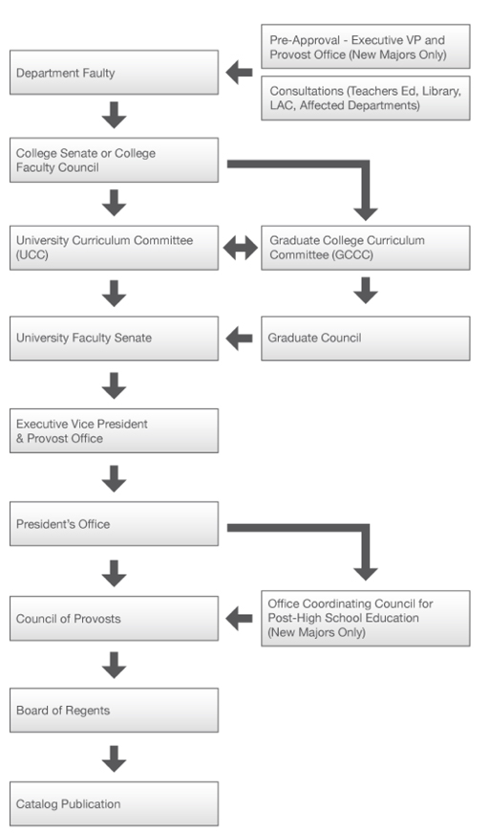

Recommendation 4
Change Policy 2.04 Curricular Changes to assure that:
- Any recommendation for program closure, originating with the faculty or with the administration, would be channeled through the regular curricular process, assuring the opportunity for consideration by faculty and the Faculty Senate.
- If the Provost does not approve the recommendations of the Senate, the Provost would provide to the Faculty Senate a written explanation of the decision.
- Expansions, divisions, and mergers of colleges, departments, schools, and programs should be reviewed by the Faculty Senate for curricular implications. At the very least, these actions could affect the composition of committees that participate in the curricular
process.
In summary, the Committee’s recommendations mandate greater faculty participation in the curricular process. Several responsibilities, currently not assigned specifically, would be affirmed as functions of the faculty:
* regular review of programs
* identification of, and working with, programs exhibiting early signs of difficulty
* consideration of recommendations for program closure originating with the faculty or with the
administration
* timely consultation during mergers and divisions of academic units.
Any recommendation for program closure, originating with the faculty or with the administration, would be channeled through the regular curricular process (shown on the next page), assuring the opportunity for consideration by faculty and the Faculty Senate. If this process results in different program closure recommendations from the Faculty Senate and the Provost, the Provost would provide to the Faculty Senate a written explanation of the decision.
We believe these functions would be expedited by a rolling timeline for curricular flow and by separate curricular paths for substantive versus nonsubstantive changes.

Barbara Cutter (Women’s and Gender Studies)
Todd Evans (Health, Physical Education, and Leisure Services)
Gayle Pohl (Communication Studies)
Ira Simet (Chemistry and Biochemistry)
Jerry Smith (Management)
Laura Terlip (Communication Studies)

