Ashley  Brink  Accounting | Nicaragua; the place where you experience once in a lifetime opportunities and unforgettable friendships. | 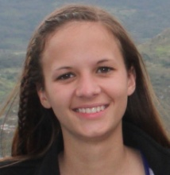
Jamie  Friis  Marketing | The Nicaragua trip is one of the best experiences of my life. Not only did I get the chance to learn about the cultural differences between the United States and a Central American country, but I got the chance to experience things I never thought I would be able to. From volcano boarding and zip-lining to picking coffee, I received a comprehensive look at Nicaragua and met so many people that have changed the way I view my own culture. | 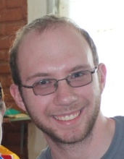
Melanie Heser  Marketing | The Nicaragua trip was definitely a journey. Learned so much about another culture, different ways of living, priorities of another country, and so much about myself. If someone were to ask me what's been my favorite experience in life, traveling in Nicaragua would be my immediate answer. The journey can never be explained in a sentence. It's an experience of a lifetime; one everyone should see for themselves. | 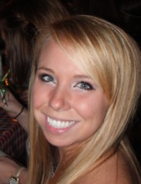
Aaron Knaack  Economics |  | 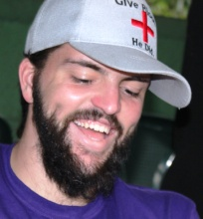
Joshua Koppes  Accounting |  | 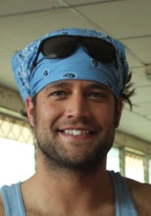
Dwayne Leighton  MBA | Nicaragua is culturally rich. It is an adventure that will touch your heart. | 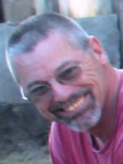
Ben  McClurg  Accounting | "Life is not about the wants, it's about the needs: Shelter, Food, Water, Love, and Family and Friends" | 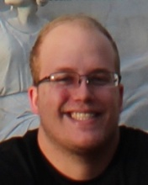
Laura Parker  Anthropology and Spanish |  | 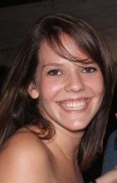
Anna  Phalen  Early Childhood Education | Friends told me that I would be itching to get back to the U.S. but the opposite happened. I found love, acceptance, friendships, and ideals I never knew were possible. I am so thankful to have had such an amazing experience. A major difference I noticed is that life is cherished in Nicaragua, it means more than money or time. The very short time I have spent there taught me to not be so rushed, cause you could miss out on something amazing and not even know it! | 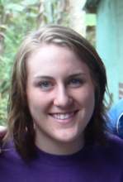
Jordan Queckboerner  Marketing | Nicaragua was an eye opening experience that I was so happy to experience. I sincerely enjoyed all of my experiences here and have meet friends that I know will continue beyond this experience. When I get back to the US I am going to change my lifestyle completely as I now know what my 3 true needs are in life: family, friends, and just enjoying every moment of life and making the best out of every situation.
Allison Schantz  Business Teaching | "Even the shortest amount of time spent with the people in Nicaragua can be life changing. This trip really opened my eyes and heart to the hardships people deal with on a daily basis that is easy to take for granted in my own life." | 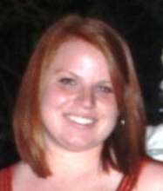
Andrea Schmertmann  Supply Chain | To be in a culture where they appreciated the littlest gift or bit of help was amazing. There are those who have little to nothing but are very content. It was eye opening and definitely made me reflect on what matters most in life. | 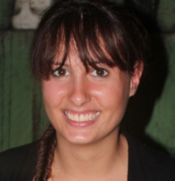
Scott  Sivola  Biology | I learned a lot about simplicity and how little one needs to be happy in this world. In the U.S. we have so many wants and are generally dissatisfied. Nicaraguans are grateful for what they have and find joy in the little things. I really appreciated their view on life and found the whole experience refreshing. | 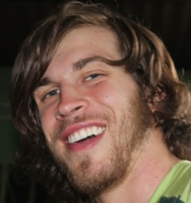
Blake  Woelfel  Marketing | Going to Nicaragua was the best experience of my life. If you ever have an opportunity to visit another country you should take it! You will be amazed what you will learn! | 